
Churches of Ludgershall and Tidworth 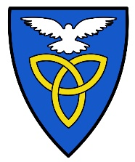
Community Magazine
Advert Request
Company/Organisation Name ……………………………………………………………………
Your Name…………………………………………………………………….
Email address…………………………………………………………………
Contact Number…………………………………………………………….

Size of advert required (please mark the size required) (cost full page £50 pcm, half page £40pcm and a sixth of a page £20 pcm)
Full Page A5 …………………… £50 pcm
Half Page A5 ………………….. £40 pcm
Sixth of a page A5 ………………. £20 pcm

Please indicate which months you wish to advertise in the 2021 magazine
Full year (11 months) …….
Jan…… Feb…… Mar…… April…… May…… June……
July…… Sept…… Oct…… Nov……. Dec…… Total Cost £…………………..
Please make payment though our stjamesludgershall.com webpage.
First go to the tab Community Magazine, down the page is Magazine Advertisements, Applepay leads you to the area for payment.
Link??? Advice?
Thank you for choosing to advertise with us
Community Magazine Development Team
Dec 2020

